Fall 2014
Infrared Spectroscopy of Gases

Background
The goal of this lab is to determine the chemical composition of various gases using a Fourier transform infrared (FTIR) spectrometer. FTIR spectrometers are the most common type of devices that measure the spectrum of infrared radiation. In this lab we will perform absorption spectroscopy, i.e. we will measure the spectrum of infrared light after passing through a sample. The samples can be solids, liquids or gases, but this lab will focus on gas samples.

Definition: The light spectrum is a plot that shows the intensity (amount) of light as a function of wavelength. Sometimes instead of wavelength another equivalent quantity is used such as photon energy or wave number.
Reminder: Infrared (IR) radiation is a type of electromagnetic radiation similar to visible light but with lower photon energy (or longer wavelength). For this reason infrared radiation is often referred to as infrared light, even though it is not visible to the naked eye.

Quantization of molecular energy: Molecules (including single atoms) can only exist in a set of distinct allowed states. Each such state has an exact energy value, specific to each type of molecule. We say that the energy is quantized, i.e. it can only take certain discrete values and nothing in between. The molecule can change (transition) from one state into another if it absorbs (receives) or emits (releases) a packet of energy equal to the difference in the energies of the two states. Therefore, each type of molecule is characterized by a unique set of transition energies. Most energies corresponding to molecular transitions are well known by now and can be found in catalogues (books, internet, etc.). By finding out the energies of the molecular transitions in a material we can figure out the types of molecules making up that material, or in other words its chemical composition.

Light passing through a sample can be absorbed by some of the molecules in the sample if the energy of the photons corresponds to one of their allowed transition energies. As a result of this process the state of the molecule is changed from a lower energy state, typically the lowest or ground state, to a higher energy (excited) state. Since each kind of molecule has a specific set of possible transition energies, the absorption spectrum for each kind of molecule is unique and can be used to identify the chemical composition of the material.
As a result of absorption, the intensity of light exiting the sample at the specific transition energies will be lower as compared to other energies. This “missing” light is easily identified in the spectrum and we will refer to the corresponding dips in the intensity of light as “absorption features or peaks”. In particular most molecules have strong absorption features in the infrared due to various molecular motions such as bond stretching and twisting. For this reason the infrared is also known as the molecular “fingerprint” region. The goal of this lab is to find a few infrared absorption features in the spectrum of several gases and to use the energy of these features to identify the chemical composition of the gases.

Experiment
Introduction
In order to contain the various gases used in this experiment, a gas box was constructed. Using Plexiglas, the box was designed to be the maximum length possible that fits within the spectrometer. The box has two pipe fitting insertions: one typically used to remove air from the box using a vacuum pump, and the other to insert the desired test gas into the box. In addition, the box has 2 Potassium Bromide (KBr) windows on the ends. KBr is used because, unlike regular glass, it is transparent to the infrared light. These windows are crucial for this experiment as they allow for the IR beam to pass into the box, through the gas sample, and back into the detector within the spectrometer.

Materials needed
- Gas box
- FTIR spectrometer
- OMNIC software
- Pipe Fittings (One end screwed into box, other end for inserting into these clasps)
- Hoses/tubing
- CO2 canister
- 100 mL syringe with tube attachment
- Sample gases: Propane, Methane

Gas box preparation
In order to create a reproducible starting environment for the experiments the box needs to be first vacuumed and then refilled with clean air from a clean air generator. The clean air generator removes most water vapor and CO2 from the air. This starting environment will be used to measure the spectrum in the absence of the sample of interest, also known as a background.
- Connect the tube attached to the vacuum pump to the sample box.
- Turn on the mechanical vacuum pump and wait a few minutes until the box is evacuated.
- Disconnect the vacuum tube and quickly attach the purging tube that provides clean air from the generator. The purging tube should be attached to the back of the FTIR at all times except when refilling the box.
- After a few minutes disconnect the purging tube and reconnect it to the back of the FTIR.
- Perform the box optical alignment if needed following the procedure described in the next section. The goal of this procedure is to get the maximum light intensity through the box in the absence of the sample for maximum sensitivity.
- Close the cover of the FTIR and wait at least 10 minutes until the machine is purged again.
- Take the background spectrum measurement using the procedure in the next section.

Spectroscopy measurements
- Begin by opening OMNIC software. For further detailed instructions on how to use this software, refer to the write-up: IR Spectroscopy Lab.
- Box alignment: Open up the software to Experiment Setup. First, begin by placing the box within the spectrometer. If you hold up a piece of paper on the right end of the box, you can see a red alignment laser beam coming through. The red laser beam follows the same path as the infrared light, so it can be used to visually track the IR radiation that is not visible to the naked eye. The red laser beam must enter the box through the center of the right KBr window, run straight through the box, and exit the box through the center of the left-hand KBr window. It may be hard to see the red laser after it exits the box. Try turning off the lights to see it. Align the box within the spectrometer as needed. Ensure that the box is both high enough and straight enough to allow the IR beam to successfully pass through the box. To maximize the signal, check the Max Peak Value on the OMNIC software during the aligning process. Make sure that the spectrum is also not distorted.
- Once the box is positioned to achieve highest Peak Value and allows for the beam to pass completely through the KBr windows on the box, secure the box in place with screws and record all parameters: Max Peak Value, Resolution, Scans, Aperture, and Gain. To find a standard set of conditions to compare to, see the Appendix.

- Background collection: Now you are ready to test the box. Take the background spectrum of the box in the standard conditions of vacuumed and purged. Compare this spectrum to the one in Appendix.
- Read the Data analysis section below and answer the following questions.
Questions: What do you think are the dominant absorption features in your background spectrum? What can you conclude from them about the chemical composition of the air in the FTIR? How can you reduce these absorption features to improve the background spectrum?

- CO2 testing: Next, we will sample CO2 within the box. Use the tube attachment to connect the 100 mL syringe to the CO2 canister. Try to minimize gaps or areas where the gas can leak out.
- Gently release the CO2 enough to fill the 100 mL syringe with gas. Once it is filled, quickly remove the end of the tube attachment from the CO2 canister and connect a pipe fitting on the end. These fittings are sealed when disconnected, so they will trap the CO2 in the syringe. The key is to allow as much CO2 to stay in the syringe.
- Taking the end of the tube with the pipe fitting, connect it to one of the pipe clasps on the Gas box.
- Next, push the syringe all the way down to allow the gas to enter the box. The syringe will immediately pop back up, to flush out the air inside of the box and keep the CO2 in—allow it to do so.
- Once the flush has finished, disconnect the syringe with the tube and pipe fitting from the box.
- Now, run a spectrum scan on the CO2 within the box. Record the experimental settings and results as done previously.

- Once the data has been collected for this gas, the box must be purged once again to return the air within it back to the controlled clean state. Follow the directions in the section “Gas box preparation” to return the box to the clean gas state and re-take the background spectrum. Allow the air within the box to purge for at least 10-20 minutes—enough to remove traces of the previous gas sample.

- Other gas testing: Once the box is completely purged, conduct the experiment by repeating steps 7-12 two more times, using Methane and Propane. Be sure to record the settings and results.

Data Analysis (and some questions**)
Now that the spectra have been found for all 4 samples of gas and air, the next step is to analyze the peaks found in the graph. The best way to find the most prominent peaks in each of the gases is to compare each gas spectrum to the controlled air, which would be the vacuumed and purged air sample.
Using the “analyzing peaks” tool in OMNIC, find the wavenumbers of the peaks in each spectrum (see IR Spectroscopy Lab for more detailed procedure to do this). Then, use the Chemical Bond Correlation Chart in Appendix to obtain specific chemical bonds for particular wavenumbers.

Analysis Questions:
- How do the chemical formulas for each of the gases (i.e., methane, propane, etc.) pertain to the chemical bonds found through analyzing the spectra?

- What do you believe the middle noise may be in all of the spectra between 1500-2500 cm-1?

- In what ways could this noise be avoided? In other words, what steps would you take to remove this noise from the samples' spectra?

End of lab procedure (to be done before you leave for more than half an hour)
Leave the box in the clean purged state when you are done testing all your gases. Close the FTIR lid and make sure the purge line is attached to the back of the FTIR. Close all Omnic software windows and exit the Omnic software altogether.

Appendix

Chemical Bond Correlation Chart
Bond | Compound Type | Frequency range, cm-1
C-H | Alkanes | 2960-2850(s) stretch
C-H | Alkanes | 1470-1350(v) scissoring and bending
C-H | CH3 Umbrella Deformation | 1380(m-w) - Doublet - isopropyl, t-butyl
C-H | Alkenes | 3080-3020(m) stretch
C-H | Alkenes | 1000-675(s) bend
C-H | Aromatic Rings | 3100-3000(m) stretch
C-H | Phenyl Ring Substitution Bands | 870-675(s) bend
C-H | Phenyl Ring Substitution Overtones | 2000-1600(w) - fingerprint region
C-H | Alkynes | 3333-3267(s) stretch
C-H | Alkynes | 700-610(b) bend
C=C | Alkenes | 1680-1640(m,w)) stretch
C≡C | Alkynes | 2260-2100(w,sh) stretch
C=C | Aromatic Rings | 1600, 1500(w) stretch
C-O | Alcohols, Ethers, Carboxylic acids, Esters | 1260-1000(s) stretch
C=O | Aldehydes, Ketones, Carboxylic acids, Esters | 1760-1670(s) stretch
O-H | Monomeric -- Alcohols, Phenols | 3640-3160(s,br) stretch
O-H | Hydrogen-bonded -- Alcohols, Phenols | 3600-3200(b) stretch
O-H | Carboxylic acids | 3000-2500(b) stretch
N-H | Amines | 3500-3300(m) stretch
N-H | Amines | 1650-1580 (m) bend
C-N | Amines | 1340-1020(m) stretch
C≡N | Nitriles | 2260-2220(v) stretch
NO2 | Nitro Compounds | 1660-1500(s) asymmetrical stretch
NO2 | Nitro Compounds | 1390-1260(s) symmetrical stretch

1. Vacuumed and Purged Air Box Spectrum
Settings:
Resolution | 4
Scans | 50
Gain | 2
Aperture | 55
Max Peak Value | 0.71

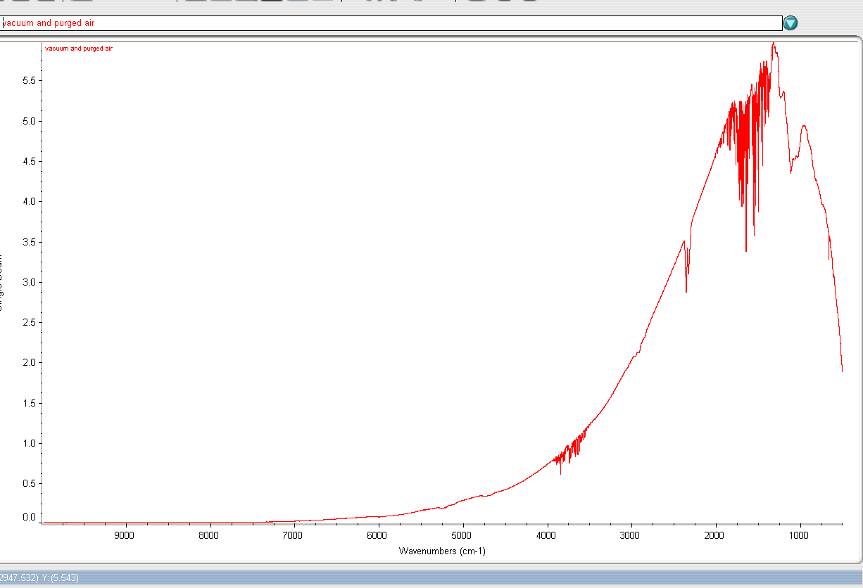
2. 300 mL CO2 Gas Sample
Settings:
Resolution | 4
Scans | 50
Gain | 2
Aperture | 55
Max Peak Value | 0.6

Analyzing Peaks
Peak Wavenumber | Possible Chemical Bond
2314.4cm-1 | CO2
669.2 cm-1 | C-H alkynes

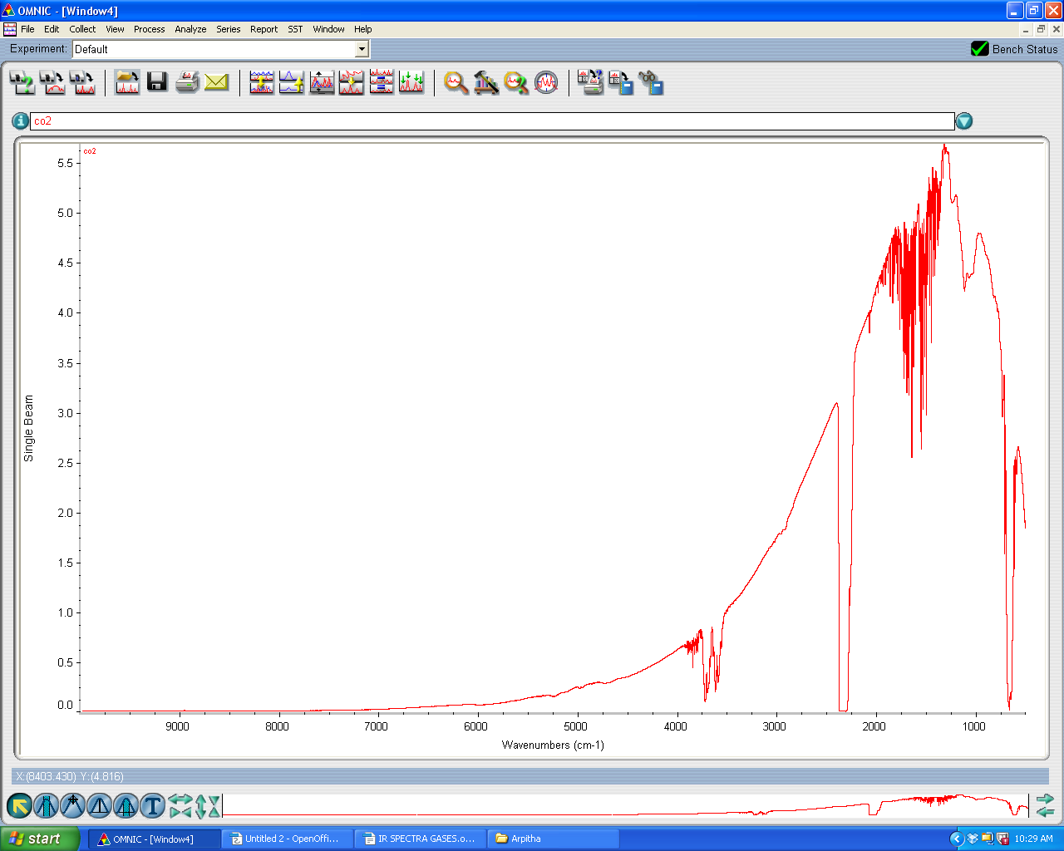
- 100 mL Methane Gas Sample
Settings
Resolution | 4
Scans | 50
Gains | 2
Aperture | 55
Max Peak Value | 1.03

Analyzing Peaks
Peak Wavenumber | Possible Chemical Bonds
3016.7 cm-1 | C-H
667.9 cm-1 | C-H

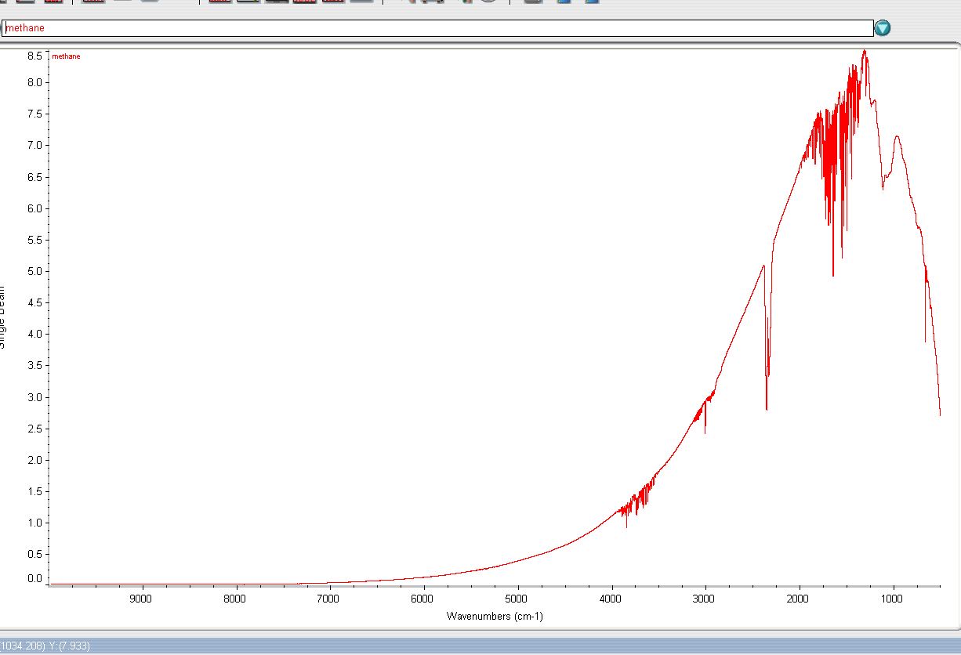
- 100 mL Propane Gas Sample
Settings:
Resolution | 4
Scans | 50
Gain | 2
Aperture | 55
Max Peak Value | 0.65

Analyzing Peaks
Peak Wavenumber | Possible Chemical Bonds
2339.7 cm-1 | CO2
667.9 cm-1 | C-H



